### **Setting up Node.js and NPM**

**Note: Make sure you have installed Git on your machine before you install Node.js. Please complete the previous Git installation exercise before proceeding with this exercise.**

#### Objectives and Outcomes

In this exercise, you will learn to set up the Node.js environment, a popular Javascript based server framework, and node package manager (NPM) on your machine. To learn more about NodeJS, you can visit [https://nodejs.org](https://nodejs.org/). For this course, you need to install Node.js on your machine. At the end of this exercise, you will be able to:

* Complete the set up of Node.js and NPM on your machine
* Verify that the installation was successful and your machine is ready for using Node.js and NPM.

#### Installing Node

* To install Node on your machine, go to [https://nodejs.org](https://nodejs.org/) and click on the Download button. Depending on your computer's platform (Windows, MacOS or Linux), the appropriate installation package is downloaded.
* As an example, on a Mac, you will see the following web page. Click on the Download button. Follow along the instructions to install Node on your machine. (Note: Now Node gives you the option of installing a mature and dependable LTS version and a more newer current version. You can install the current version. I will use this version in the course.)

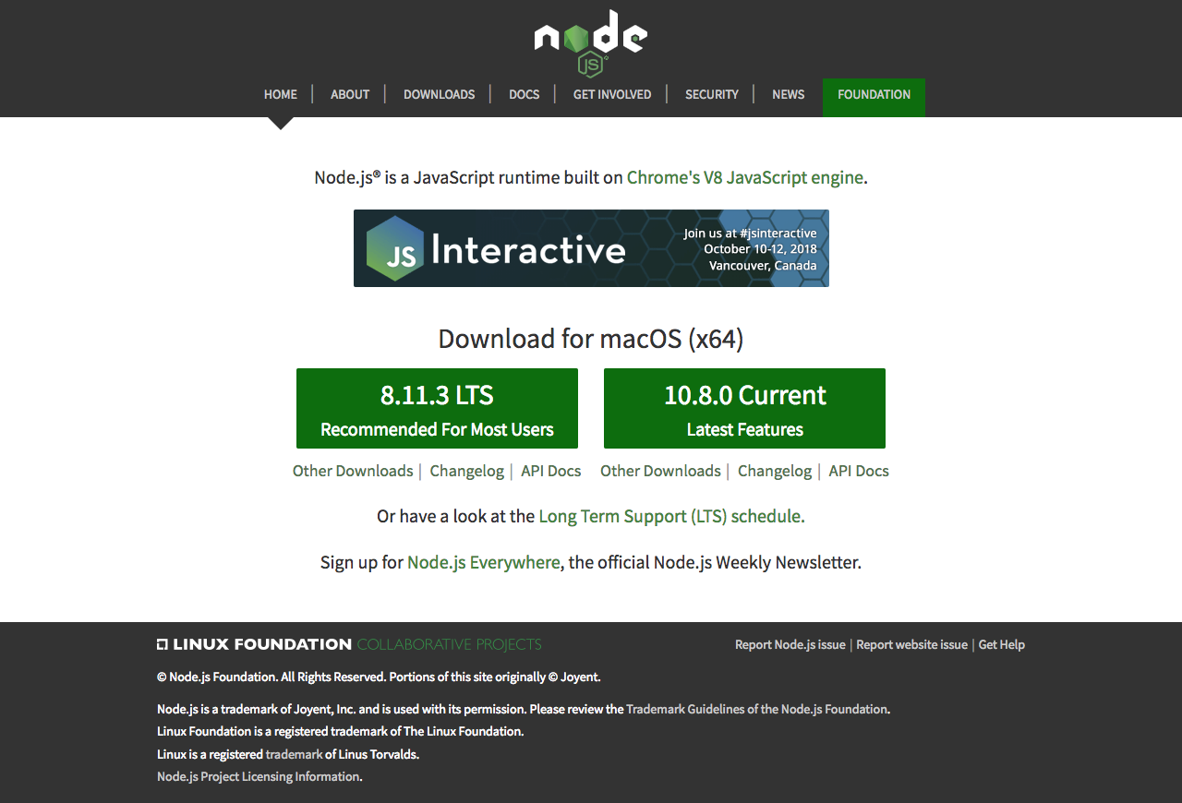

**Note: On Windows machines, you may need to configure your PATH environmental variable in case you forgot to turn on the add to PATH during the installation steps.**

#### Verifying the Node Installation

* Open a terminal window on your machine. If you are using a Windows machine, open a cmd window or PowerShell window with **admin** privileges.
* To ensure that your NodeJS setup is working correctly, type the following at the command prompt to check for the version of **Node** and **NPM**

node -v

npm -v

#### Conclusions

At the end of this exercise, your machine is now ready with the Node installed for further development.